Netflix Movies & TV Shows Summary

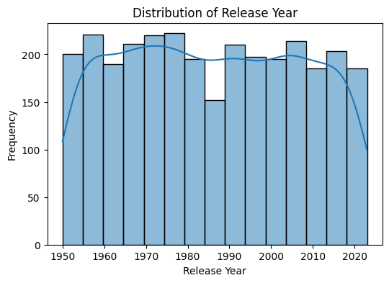
Insights :
- Most content is released after 2000
- Very few titles exist before 1980
- Dataset is skewed toward recent releases

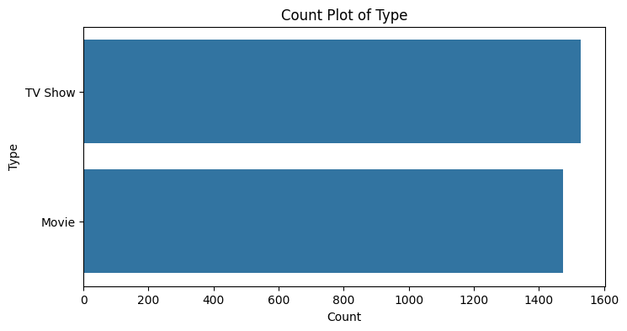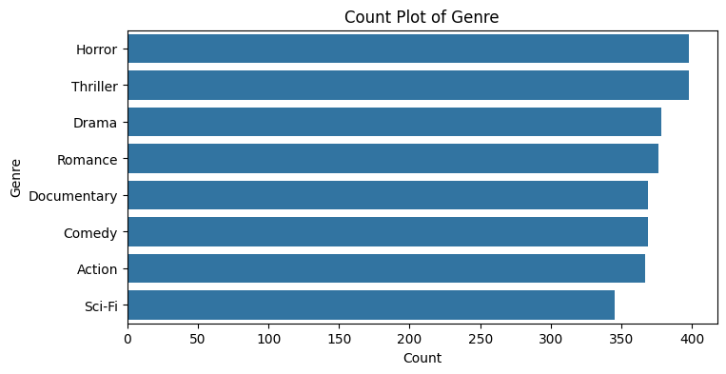

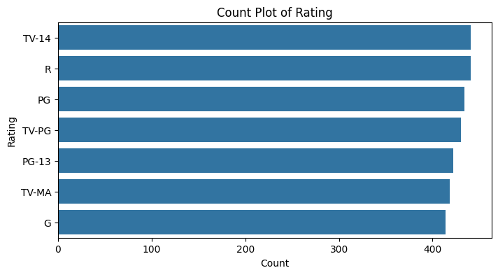

Insights :
- TV Shows slightly exceed Movies
- Genres like Drama, Thriller, Horror dominate
- Ratings show Netflix targets wide age groups

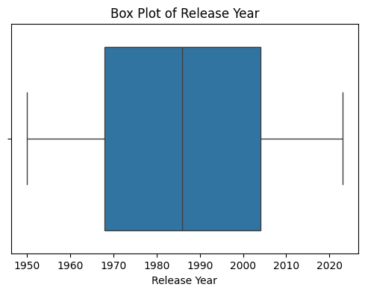
Insights :
- Older release years appear as outliers
- No extreme invalid values found
- Data quality is good

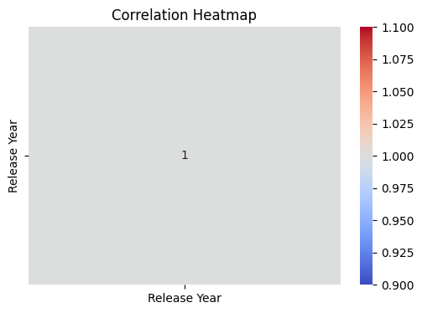
Insights:
- Only one numerical column → limited correlation
- Adding duration, seasons, ratings improves analysis

INSIGHTS:
1. Netflix content is heavily focused on recent years.
2. TV Shows are more common than Movies.
3. Drama, Thriller, and Horror genres dominate.
4. Older titles are fewer and act as outliers.
5. Dataset has minimal anomalies.

Important Features for Prediction:
- Type
- Genre
- Rating
- Release Year
- Country
- Duration

SUMMARY:
• Netflix prioritizes modern content.
• TV Shows slightly outnumber Movies.
• Certain genres dominate the platform.
• Release year shows strong skewness.
• Dataset is clean and ML-ready.
• Suitable for EDA and ML projects.

************************* THANK YOU ***************************

